1.

|  |  |  |  |
| --- | --- | --- | --- |
| C | B | A | Salida |
| 0 | 0 | 1 | 0 |
| 0 | 1 | 0 | 1 |
| 0 | 1 | 1 | 0 |
| 1 | 0 | 0 | 1 |
| 1 | 0 | 1 | 1 |
| 1 | 1 | 1 | 1 |
| 0 | 0 | 0 | 0 |

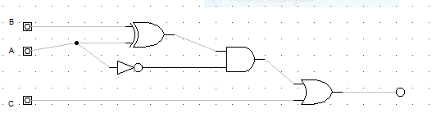

2.

|  |  |  |  |  |  |
| --- | --- | --- | --- | --- | --- |
| Decimal | D | C | B | A | salida |
| 0 | 0 | 0 | 0 | 0 | 1 |
| 1 | 0 | 0 | 0 | 1 | 1 |
| 2 | 0 | 0 | 1 | 0 | 0 |
| 3 | 0 | 0 | 1 | 1 | 1 |
| 4 | 0 | 1 | 0 | 0 | 0 |
| 5 | 0 | 1 | 0 | 1 | 0 |
| 6 | 0 | 1 | 1 | 0 | 0 |
| 7 | 0 | 1 | 1 | 1 | 0 |
| 8 | 1 | 0 | 0 | 0 | 1 |
| 9 | 1 | 0 | 0 | 1 | 0 |
| 10 | 1 | 0 | 1 | 0 | X |
| 11 | 1 | 0 | 1 | 1 | X |
| 12 | 1 | 1 | 0 | 0 | X |
| 13 | 1 | 1 | 0 | 1 | X |
| 14 | 1 | 1 | 1 | 0 | X |
| 15 | 1 | 1 | 1 | 1 | x |

Código inst: 30000030138

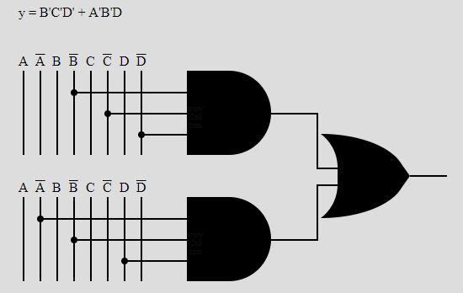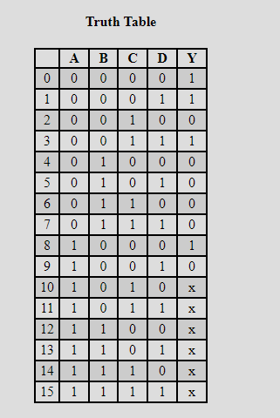

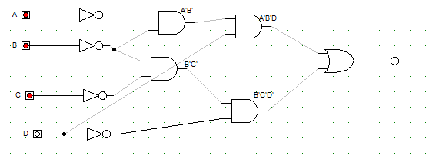

20151615041

